## LAB 11

ImplementING uninformed search techniquies

###### OBJECTIVE:

Finding shortest path using BFS and DFS search technique in python.

**Lab Tasks: -**

**Q1:** Apply Breadth First Search on following graph considering the initial state is A and final state is G. Show results in form of open and closed list.

**OUTPUT:**

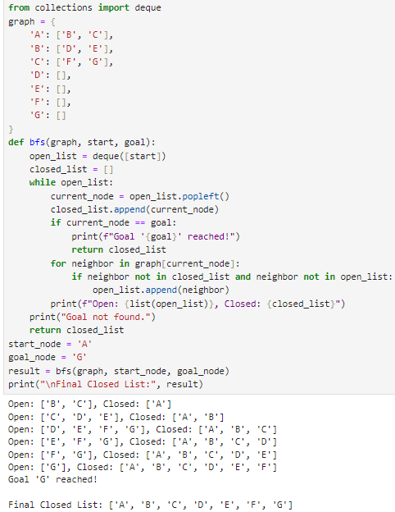

**Q2:** Using Question no. 1 apply BFS by taking initial and final state as user input. Show results in form of open and closed list.

**OUTPUT:**

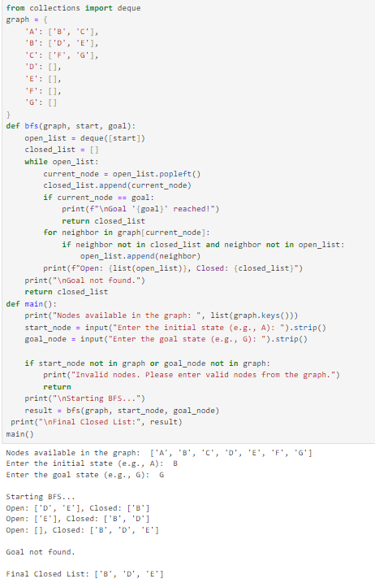

**Q3:** Apply Depth First Search on the graph given in question 1. Considering the initial state is A and final state is G. Show results in form of open and closed list.

**OUTPUT:**

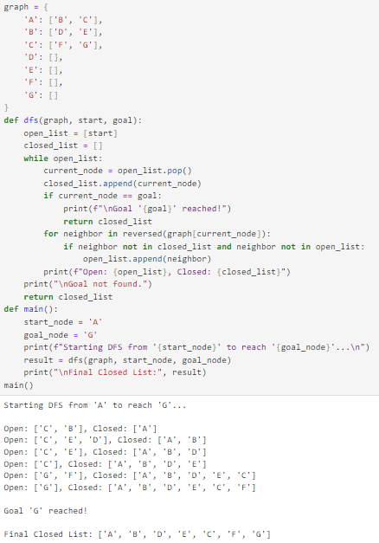

**Q4:** Using Question no. 1 apply DFS by taking initial and final state as user input. Show results in form of open and closed list.

**OUTPUT:**

